Pembrey Junior Duathlon Round 1
02/04/2022
National Closed Road Cycling Circuit
Pembrey Country Park SA16 0EJ

First Race starts 13.00hrs Reg. open from 12.30hrs

COVID-19 expectations

Please familiarise yourself with the current Pembrey Country Park rules around Covid-19 here
Pembrey Country Park and Beach

Additionally you will be expected to follow the current and up to date Welsh government Guidance which can be found here

Coronavirus (COVID-19) | Topic | GOV.WALES

No spectators can enter the area of race. You will be allowed around the outside of the circuit. This is a public area and you will be expected to adhere to the park rules and expectations linked above.

If you have any symptoms please do not attend.

If you or someone from your household has been asked to self isolate do not attend.

Information of all Participants will be used and shared, should they be requested, with Welsh Government officials. Details will not be passed on to anyone else.

There are no changing facilities available. Participants are expected to arrive race ready and leave after their race has finished.

Car parking charges should be paid before exiting the park. Please see Pembrey Country Park website on costing and details of how this works.

Toilet facilities will be available at the Ski lodge building (see map near the end of the document). These are public toilets. You will be expected to wear face coverings when indoors.

The designated parking area for all participants is next to the race circuit and is labelled on the map below.

Please wait to be directed by a Marshal to enter this area.

Race Information Pack

May I take this opportunity on behalf of Celtic Tri to thank you all for supporting this event.

Please take time to read the following. It is important for the smooth, safe and enjoyable running of the event.

Mark Edwards, Race Organiser.

WARNING: -
IF YOU MISS YOUR RACE START TIME YOU WILL NOT BE ABLE TO RACE IN A LATER CATEGORY
Registration / Briefing
- From 12.30 onwards, near the entrance to the race circuit.
- Registration will be rolling with the need to sign up 20 mins before allocated start time.
- You will be issued with a race number and bike sticker.

- Bikes will be permitted into transition immediately for the first race (Tri Starts). Once they have finished racing the next category will enter and set up.

- Race briefing will be supplied online on Friday 01th of April 2022 via a Zoom call. This information will be sent out with links. Additionally, on the day, a short briefing will take place before each race starts.
- This is a non drafting race and will be following British triathlon rules.
- Please familiarise yourselves with the up to date rules here
Competition Rules – British Triathlon
Numbers

- Race numbers should be visible to marshals, on front and rear of your vest/top and on bike frame. Race belts are permitted.

Run section 1

This will be situated next to the transition area.
The run loop is on a traffic free road within the circuit. The loop is 800m
(Tstarts half loop, T1 1 loop, T2 1 loop, T3 and Youth 2 loops)

Upon finishing the run section you will go straight into the transition area.

Cycle section

Please try to have a number visible on your back and be ready to shout out your number to marshals.
- Any competitor drafting (slipstreaming) behind another competitor may be disqualified. There should be at least 4 bike lengths between cyclists, except when overtaking.
- Be sure to fasten your helmet BEFORE touching your bike.
- Do not mount your bike until you reach the “mount” line indicated on the floor by a marshal and a visible line.
- The cycle section of this race consists of a 1600m closed road lap (TS 1 lap, T1 2 laps, T2 3 laps, T3 and youth 4 laps)

Run section 2

IMPORTANT: Do not remove your helmet until you have put down your bike or you may incur a penalty.
The run course is then the same loop as before. In some of the races you will be instructed to turn at around half way around the first loop to keep in line with race distance regulations (T1 half loop T2 half loop T3 and Youth 1 loop)

Once you have finished the race you will help yourselves to water and a medal. There will be prizes for podium places which will be collected at this point after you cross the line. There will be no formal presentation.

The Route.
Venue overview

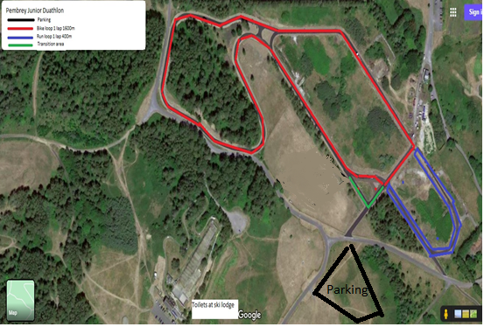

TRANSITION AREA

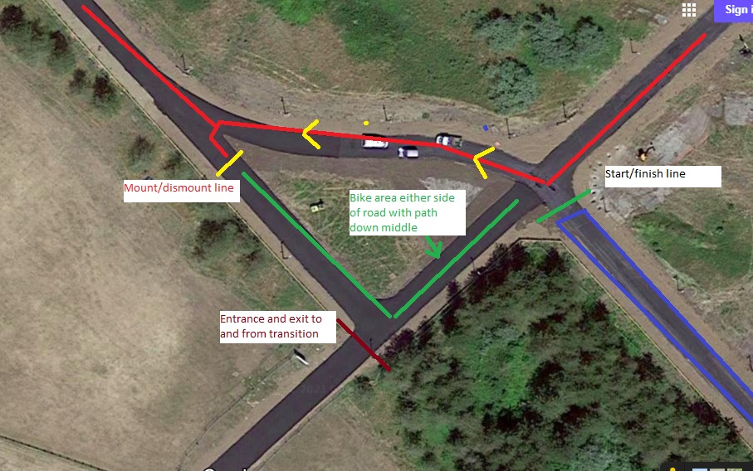

Rules hints and tips

- Transition area- There is no riding your bike in transition.
- Drafting - Drafting is not allowed in this race, it is where a cyclist tucks in behind another cyclist to avoid oncoming wind and making his or her race easier. See British Triathlon drafting rules.
- Mount line - This is the designated area marked out where you push the bike to from transition and then and only then do you mount your bike, likewise it is where you dismount the bike on the return from the bike section.
- Number belt- A race belt can make your transition easier, it is an elasticated belt where athletes can pin their race numbers to. (Not compulsory, your number can be pinned on the front and back of your t shirt or running top.
- Race Numbers – These must be visible at all times on the Bike (facing backwards) and run (facing forwards) section.
- Helmets – These must be compliant to British safety standards and must be fastened prior to unracking the bike and must remain fastened until the bike is put down
- Marshals and Race Officials have given up their own time to assist in the running of this event. At no time will abuse towards marshals be tolerated, any such abuse will result in disqualification.

Timing

There will be no timing of this event, results will be issued and collated on a finishing position basis only

Rules are there for fairness and safety, there will be where possible be an inform and not penalise approach, however penalties may be enforced if required.

