Return to open water swimming at Glynneath Lakes will be starting from Monday 10th May 2021.

As in previous years all members will be required to sign a disclaimer if they wish to use this facility as these are not club lead or coached sessions and swimmers will swim there at their own risk and will not covered by club insurance.
Due to COVID, the size of groups allowed to meet up (max 30 people) will put some restrictions on how many swimmers can attend and as such the lakes manager has given clubs extra days/hours to swim. All swimmers MUST now follow these guidelines, otherwise lake access will be withdrawn from clubs this year.

Access to lakes, days and times

As we share the lake with other triathlon clubs and water users (Jetskis, water skiing, divers), each club has been given a dedicated night to swim and we also have shared club swims outside of this night.

- Morning lake swimming available to all clubs from Monday to Saturday 7am – 9am (out of the water by 9am) up to 10 spaces will be allocated to each club. This will be one booking slot.

- Clubs will have an exclusive 90-minute session each week between the hours of 6pm – 9pm (out of the water by 9pm) 30 places will be available to each Club. We share our night with PTH.
Tuesdays - Celtic Tri and Port Talbot Harriers

Thursdays - Rhondda Tri and Merthyr Tri

Allocated clubs nights will rotate weeks so they will have an early session (6pm – 7.30pm) and late session (7.30pm – 9.00pm)
A system will be in place to allow a clear transition for clubs leaving and entering the lakes, this to be confirmed on the Members Lakes Facebook group.

There will be a Friday session available to all 4 clubs and up to 10 spaces will be allocated to each club. This session will be from 7:30pm – 9pm. This will be one booking slot.
All sessions will be required to be booked via the clubs’ own track and trace system and made available for 21 days to other clubs, if any club member the shows signs or symptom of COVID.

THERE IS NO ACCESS TO THE LAKES ON WEEKENDS AFTER 9am

YOU MUST NOT USE THE LAKES OUTSIDE OF THESE TIMES

The main guidelines of use are:

- Must be a Celtic Tri member and have your membership card with you at all times when using the lakes. You may be challenged by the owner or a representative when you attend and will need to show your card.

- Must have a signed a disclaimer to use the lakes. This needs to be done before visiting the lakes and it only needs to be completed once a year when registration for the lakes open.
A copy of the disclaimer will be kept with the club and a copy is sent to the lake’s owner. There are no exceptions to this. If you miss the registration period, you can register by contacting a committee member.

- Must use the dedicated Facebook Group [GLYN NEATH LAKES CELTIC TRI MEMBERS] for organising swims, informing the group about any issues at the lakes and for checking in and out. See below for checking in/out.

- DON’T SWIM ALONE. As tempting it may be to go there on a summer’s day, you must not swim alone. If you are caught or reported, you will be banned from Celtic Tri, no exceptions! Remember our allocated swim times too.

- There is limited parking at the lakes and the road is a shared with 2 neighbours who don't want hundreds of cars travelling along the road. Minimise the number of cars entering the lake, while maintaining social distancing when possible. You may be required to walk to the lakes. Park and walk to the lakes (about half mile down the track)

  - park in large layby on main road (Marked as Parking 1 on the map)
  - layby opposite turning into the lane (Marked as Parking 2 on the map)
  - McDonald’s carpark/layby (Marked as Parking 3 on the map)

- Don't use the larger lake if there are powered craft are using it!
- Don't give the Gate code to anyone else, or publish it outside of the closed Glyn Neath Lakes Facebook Group

- With the additional hours allocated to the Triathlon clubs there should be no need for swimmers of clubs to swim outside of these hours, members that swim outside of these hours will be trespassing if they do.

- Entry and exit is being monitored by the neighbours and will be reported back to the lakes manager if cars are speeding or a large number of cars are turning up.

- Allocated places for parking once inside the lake, is near the large lake

- All sessions must have track and trace in place. This will be via booking system.

Check in and out system

A new Facebook group has been created for all Celtic Tri registered users of Glyn Neath Lakes. Facebook Group is called Glyn Neath lakes Celtic Tri members. You will be added to the group once we have received a copy of your disclaimer.

This group is managed by the Celtic Tri committee and will be used for registered members to organise swims at the lakes and for checking in and out.

There will usually be a lead organiser on club night and other times, and it will be their responsibility to check members in and out on the night via the group. At other times it will be individual’s responsibility to notify the group that you are swimming with someone there.
You must post how many are swimming and the time of when you go in and come out. If you can post names that would help to us to ensure that only members are using the facility and if you can report on any activity or abuse that is going on at the lakes so we can keep the owner updated. Examples of this might be no car sharing by other clubs, gates left open, padlock not locked.
If there is an incident or near miss please report this to a committee member ASAP.

General notes

We are charged annually as a club to use the lakes and its currently FREE for registered members to use the lakes providing they follow the guidelines above.
Our bill for using the lakes is based on numbers using the facility, so its important for you to provide us with this information so we know how many actually use it and having names we can see if its new users or regular users who use the lake, this information may reduce our annual bill and help to keep it FREE for our members!

If we don't follow these guidelines, then the owner may stop access to this facility

Not compulsory but recommended due to the remote location of the lake is a floatation device which can be towed behind you. This can be used in case of cramp or fatigue and as a visual guide for anyone not swimming who are providing land cover at the lake edge.

COVID specific guidance

- All swimmers are to book their swim session via Eventbright (Track, Trace, Protect system)
- All swimmers are required to have hand sanitizer and wear gloves to open the gate lock
- All swimmers to adhere to current social distancing rules when at the lakes.
- A reminder that there is to be no physical contact between swimmers from different households at any time.
- Swimmers to maintain 2m apart when swimming and swim in small groups of 2-6
- Please take any litter home with you and keep the lake area tidy.
- All swimmers must undergo a self-assessment for any Covid-19 symptoms
No one should leave home to participate in any activity if they, or someone they live with, has any of the following:
  - A high temperature
  - A new, continuous cough
  - A loss of or change to their sense of smell or taste.
- Due to lockdown, a participant’s level of fitness may have changed, particularly in terms of swimming where they may have been unable to access pools. All swimmers should think about their perceived level of fitness and ensure that they feel confident to participate fully in any activity.
- Should you develop Covid 19 symptoms in the days following swimming, it is imperative that they notify the club COVID Officer as soon as possible.

Procedure for registering to swim at Glyn Neath lakes

- Download a copy of the Glyn Neath Lakes Disclaimer form from the website under the menu Training > Open Water Swimming.
- Download/View a copy of the Risk Assessment and Emergency Action Plan for coached sessions.
- Complete the disclaimer, sign and datem then email to committee@celtictri.co.uk for approval
- Once approved you will be added to the Facebook Group - GLYN NEATH LAKES CELTIC TRI MEMBERS

- If you cannot complete the disclaimer and provide proof of your membership using the above procedure, you can register at any club coached session, where the coach will be able to validate your documentation.

Parking at Glyn Neath Lakes.
Where ever possible we need to car share, providing social distancing can be maintained
Suggested areas include:
- Park in large layby on main road (Marked as Parking 1 on the map)
- Layby opposite turning into the lane (Marked as Parking 2 on the map)
- MacDonald’s carpark/layby (Marked as Parking 3 on the map)

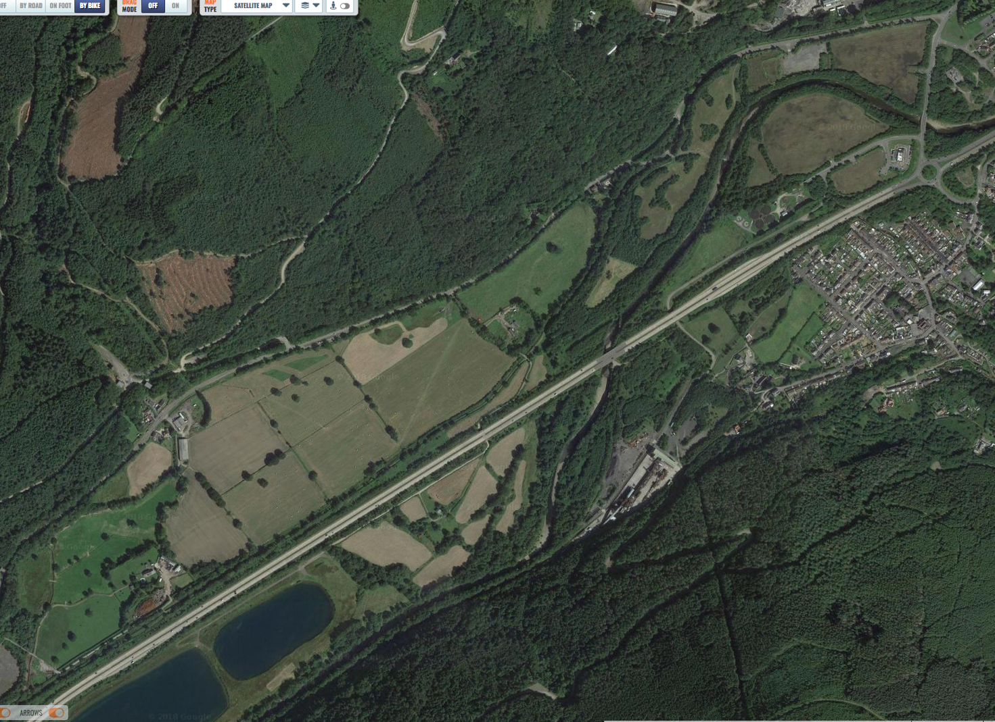
1
3
2

