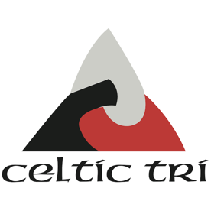
GLYN NEATH LAKES & CELTIC TRI DISCLAIMER

Glynneath Lakes: Participants must sign declaration and be approved before entering the water.

I ............................................................... declare that I am a paid up member of Celtic Tri and participate in open water sessions at Glynneath Lakes, accepting full responsibility for my own welfare, and enter with the knowledge that I am medically fit and healthy to take part.

I am aware of all the risks involved with open water swimming, both coached and un-coached, I enter at my own risk, and I will not hold the Session Leader, Celtic Tri or the Owners/Managers of this facility responsible for any injury or damage caused as a result of my actions.

I have read and understood the Guidelines and Procedures for using the Glyn Neath Lakes that was made available to me on the Clubs Website.
I understand that a tow float is recommended for all swimming activates at the lakes.

Celtic Tri Membership Number ................................

Signature ................................................................. Date ...........................................

Once you have completed the disclaimer in full, email it to committee@celtictri.co.uk
You then need to ask to join the private members Facebook group https://www.facebook.com/groups/glynneathlakes2021membersonly/

Once approved you will be added to the Facebook group and you can start swimming at the lakes.

Official use only: Disclaimer for 2021 season
Membership validated by ............................................................. Committee Position .........................................

Date ............................................ Added to Facebook Group by ........................................ Date ....................

Celtic Tri Open Water Disclaimer – Glynneath Lakes – Version 5.0 Season 2021

