Celtic Tri AGM minutes – 16th February 2018
Committee Members present – Mark Evans, Tracey Williams, Adele Francis, Phil Kethro, Lisa Kethro, Debs Longman, Paul Arnold, Richard Clifford, Jodie Dennis, Carl Cresswell

Attendance
Jon Charles, Mark Truman, Andrew Jenkins, Darren Beddows, Steve Woodward, Kevin James and Mrs James, Jacquie Fox, Anthony Fox, Nikki Powell, Ant Hobbs, Nigel James, Lisa James, Dan Evans, Mark Edwards, Hayley Harris, Jen Aylward, Jon Carrick, Emma Bond and partner, Sophie and Iestyn Williams and Dad, Richard and Jayne Leary, Eirian and Rachel Evans.
Apologies
Diana, Mia and Josh Cleave.
AGM
The meeting was opened by Mark Evans who thanked everyone for attending. Mark said a big thank you to – Paul Arnold and Mike Tate for use of the venue, Tom (the bike bloke) for the bike maintenance demo and Victoria Prendiville (Nutritionist) for the nutrition talk and demo.
Richard and Mark for the junior session beforehand.
Mark also thanked Helen and Marc Jenkins for their work with the younger club members and for the Q&A session.
The annual report for 2017 was received and approved.
Proposed - Tracey Williams
Seconded - Nikki Powell
Receive and Approve Annual Reports
- Junior Officer Report (Richard Clifford)
2018 was a record breaking year for the Celtic Tri juniors - a record number of members and a record number of podium finishes in Tri-Star’s series and non-Tri-Star’s series races.
Our juniors competed with distinction in races across the whole of Wales and, aside from their performances, they also won many admirers for their team spirit and impeccable behaviour. We were the best represented and best supported club in the series.
The third staging of our own Tri-Star race, the Stephen Lewis Aquathlon at Ystradgynlais, was another huge success and many thanks to our head coach Mark Edwards for his tireless work in organising it and to all those club members who volunteered on the day. This year’s event is on course to be another sell out.
We hosted the first Swansea Junior Triathlon in Penlan and thanks to Hayley Harris for all her work in organising that.
Also our chairman Mark Evans collected the Go-Tri organiser of the year from Welsh Triathlon after our successful three race Aquathlon series at Penlan, Morriston and Penyrheol, events which gave many youngsters their first taste of multi-sport racing.
Among the other highlights were our first club away-day trips to the Cerist Aquathlon and Aberystwyth Junior Tri.
For the first time as a club we have entered juniors into the Gwent Cross Country League and several will be competing in next weekend’s Welsh championships in Pembrey.
Our Tuesday and Thursday swim sessions now have waiting lists and junior numbers at the Friday and Sunday sessions have also increased hugely this year. Wednesdays track session is regularly attracting more than thirty and up to 45 youngsters. Also we run Saturday morning bike sessions and we are now officially the best represented club at the Gnoll Junior Parkrun.
Our annual presentation took place in December at the Mond Club in Clydach. Mia and Josh Cleave were named as our junior athletes of the year and there were a host of other awards handed out including the Stephen Lewis award which was given to Millie Jenkins who raised more than £1000 for Sport Relief last year.
Thanks to Eden Davies and Josh Wallace who, as last year’s junior captains, offered so much support to the younger children. Our 2019 captains will be Bethany Clifford and Zac Beddows and good luck to them.
We are fortunate to have an amazing group of parents and grandparents who help and support the club in many ways and it is much appreciated. Special mention to Carl Creswell, Darren Heath, Mark Truman, Hayley Harris and Jayne Cox whose work has taken some of the load off the coaches.
Finally, I would like to thank fellow coaches Tracey, Nikki and Dave and especially head coach Mark Edwards for the huge amount of work they have put in this year. With such a huge increase in numbers and sessions it has been hard work but always rewarding when we see the improvements in the youngsters.

- Comms and Marketing (Tracey Williams)
There was a target to send out the Celtic Tri newsletter on the 1st day of each Month during 2018 which was 100% achieved. The chart above shows the open rate, click rate, and industry average open rate.
We have a fairly high open rate, with our highest being 76.92% in May, and our lowest being 49.49% in March. Newsflashes, which are also included in the above chart, had an average open rate of around 30%. Our click rate is below the industry average, indicating that a fairly low percentage of readers use the links that are provided within the newsletter. These links, however, tend to be to specific email addresses or to external websites where additional information can be found.
Whilst still higher than the industry average, recent newsletters have been less popular so any feedback or suggestions on how to keep it interesting would be most welcome.
*Tracey requested more input from members
*Possibility of piloting a podcast

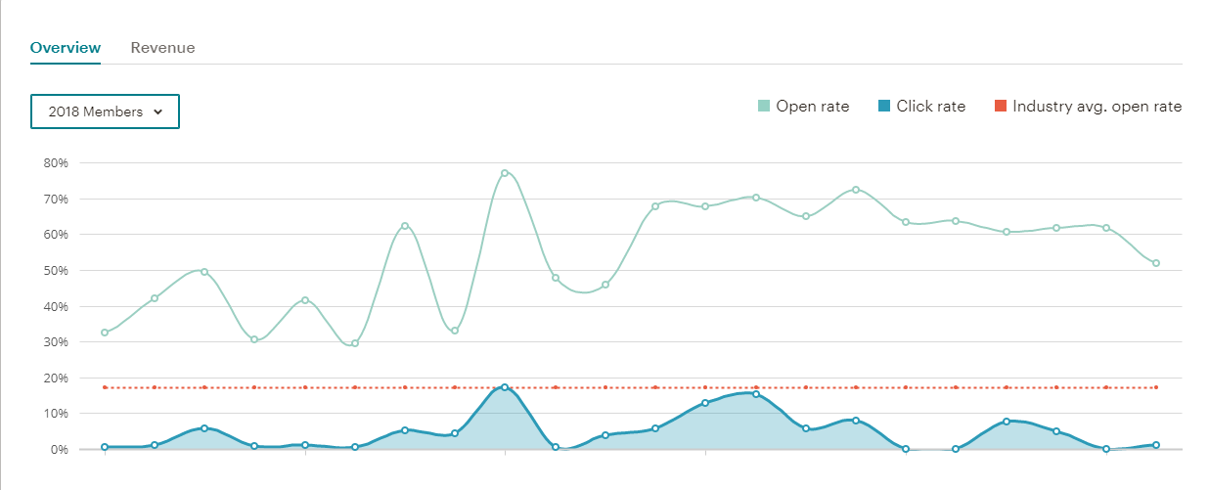

- Social and Fundraising (Debs Longman)
It has been a good year for the club. The main social event of the year is the Club Annual Awards dinner, which was held at the Marriott. In total, 88 people attended. We awarded our annual club championship winners, welcomed more new Ironman finishers into our ranks and provided awards for excellence to several members.
We are looking at potential venues for 2019. The date will be in November. Look out on the club page for options.
Fundraising has gone well this year. We have invested in a new tea urn which has allowed us to more easily provide tea’s and coffee’s for events. Funds from tea sales have gone towards the fundraising for Velindre and invested back into the club for coach development.
New for 2019, we will be looking at a first “virtual race” which will be open to adults and juniors. The money raised from the virtual race will be invested into coach development.
My post is up for re-election in 2019, I have chosen to stay in post should the members want me.
To 2019, we are the best triathlon club. CT Rocks
*Possible new venue for 2019
*Online pole Friday or Saturday
*Virtual race 2019

- Welfare Officers Report (Jodie Dennis)
The role of Welfare Officer is to ensure that children, young people and vulnerable adults are safeguarded during their contact with the club, and to ensure that the Club fulfils its duties to implement and maintain child protection policies and good practice.
During the 2018/19 season, there were no safeguarding concerns brought to the attention of the Welfare Officer that required reporting to statutory bodies.
Issues that the Welfare Officer was involved with included:
Advice regarding DBS checks and compliance with GDPR
Assisting with queries regarding event volunteers
Assisting in the management of grievance process
Contributing to the development of the new procedure for complaints
Priorities for 2019/20 season:
Safeguarding training needs analysis of coaches and committee members
Review of DBS checks
*No safeguarding concerns
* More advisory role
*Audit for 2019

- Events Report
6 racing events this year including ...
3 Go Tri events (£800 160 entries) Penlan Aquathlon Morriston Aquathlon Penyrheol Aquathlon
Steve Lewis Tri-Star’s Aquathlon – Mark Edwards
Swansea Junior Triathlon @ Penlan – Hayley and Mark
Neath Valley Triathlon Carl, Richard and Lisa
Beach picnic July - 60+ members attended Port Eynon Beach
Will be good to have Hayley on-board as events officer and I’m sure we’ll all support her and the club in staging more events this year.
Including Swansea Junior Triathlon, Steve Lewis Aquathlon and 1-2 GO TRI events (Junior and senior)

- Coaches Report
Coach Co-ordinator Report
Coach Development
Level 1: Dan Evans and Jon Carrick (2018)
Level 2: Andy Elliott and Dave Jones (2018)
Level 2: Jon Carrick (2019)
Level 3: Robert Govier (2018) Own Funded

We have 4 organised club sessions at:
Neath Pool
Pontardawe Pool
Morriston Pool (Sunday)
Cwrt Herbert Track

Other sessions include:
Morriston Pool - TnT mornings (Tuesday and Thursday)
Ystradgynlais – Junior Session
Felindre Bike – Junior Session
WATT bike session at Tri-Fit – Danni and Alex

Venues
Glyn Neath Lakes, TBC
PoW Dock, TBC
Felindre Park and Share -Licence to use for cycling activities/running

- IT Web and Social Media

- Membership Secretary Report (Lisa Kethro)

Membership Report
From January 2018 – December 2018.
Total Members - 393
Adult Members – 285 (246 L/Y)
Male 262 (166 L/Y) Female 131 (80 L/Y)
Junior Members – 108 (71 L/Y)
Oldest ‘active’ member 73 years old!

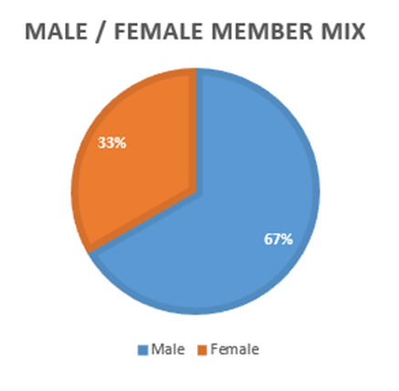
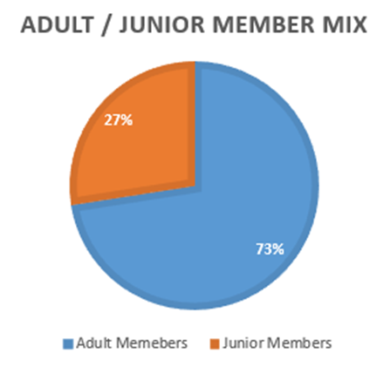
- Treasurers Financial Statement for the year
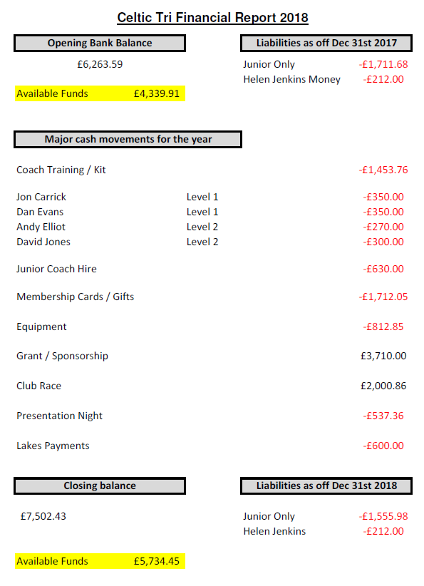

- Chairman’s Report
In 2018, the club had a set of aims and objectives, these included:
A review of our coached sessions (members completed a survey from in Dec 2017)
Accessible venues for all members to attend quality coached session sessions
Develop skill sets for club coaches and support new coaches coming through the ranks
Development of an online booking app/software for members to register for sessions/renew membership/purchase club kit
Development and investment into our Junior Section
Appoint a fundraising officer who will assist in generating additional income to the club and for this to be reinvested in future club developments
Support our talented athletes both juniors and age groupers who race for the club. Highlights for the year included Welsh Triathlon Super Series.
Celtic Tri 3rd placed club
Nathaniel Harries – Junior Champion
Jen Aylward 1st Female 50+
Nigel Morse 1st Male 50+
Success at local races across the age groups
over 40 podiums in club races
Junior Membership over 100
Juniors Competing in the Gwent League XC
Record number of podiums in Tri Stars and Non Tri Star events
Investment in Coach Development from Community Grant and club money
Receiving the Welsh Triathlon GO TRI event organiser of the year award
Welsh Triathlon Coach of the Year award
Several nominations for members for other Welsh Triathlon workforce awards
Mike Jones for being nominated for Community Coach of the year with Swansea Sports Awards in March, good luck...
Men’s and Ladies XC comeback, thanks to XC Captains Jon and Jacquie this year.
Both Men’s and ladies race at Gnoll in March is a crucial race for the club, good chance of topping the table for the men and the ladies need to stay out of the relegation spot.
Supporting our talented athletes who race for the club, Jon Carrick IM World 70.3 Championships and Team GB

- Club Championships
Introduced a new age group last year 15-19 year olds with only 2 entries (Nathanial Harries and Eden Rae Davies)
Age Group 20-29 saw just 2 entries (Chris Davies and Mary Lewis)
** NEW for 2019 ** Subject to numbers in age group category 15-19 and 20-29, the committee and club championship organiser reserve the right to merge these two age groups into one 15-29 age group. We will see what the entry numbers are like at mid-season.

- Proposed addition to the Clubs constitution

(a) Proposed wording of additional part:
10. Complaints, Disciplinary and Appeals Procedure
A complaint can be made against any member, volunteer, coach or official of Celtic Tri where the complainant believes the person(s) actions amount to misconduct and/or a breach of the Club Code of Conduct or Coaches Code of Conduct or Club Constitution.
Where possible the Management Committee of Celtic Tri will seek to resolve complaints informally at a member, volunteer, coach or official level.
All complaints regarding the behaviour of members should be submitted in writing (notification by telephone can be accepted but must be followed up by email or postal communication within 7 days) to the Club Secretary who will investigate the complaint. If the complaint is about the Club Secretary, then the submission should be made to the Chairperson instead.
The Management Committee will meet to hear complaints within 21 days of a complaint being lodged. The committee has the power to take appropriate disciplinary action including the termination of membership.
The outcome of a disciplinary hearing should be notified in writing to the person who lodged the complaint and the member against whom the complaint was made within 14 days of the hearing.
There will be the right of appeal to the Management Committee following disciplinary action being announced within 7 days. The committee should consider the appeal within 14 days of the Secretary receiving the appeal.

Full details of the clubs Complaints, Disciplinary and Appeals Policy and Procedure is available for all members on request and also posted on the club website.
(b) Proposed location of additional part
To sit between currently 9. Meetings and 10. Dissolution as 10. Complaints, Disciplinary and Appeals Procedure. Dissolution will then become point 11.
(c) Reason for addition
Celtic Tri is committed to providing a fair, consistent and proportionate approach to the handling of Complaints. The Complaints, Disciplinary and Appeals Policy and Procedure is designed to provide an open and transparent route for Complaints made under this procedure to be resolved fairly within a reasonable period of time.

- Election of Officers

Deputy Chair Mike Jones
I would like to continue my role as deputy on the committee".
A brief rationale: I am experienced in the role, having a vast knowledge of the sport and current mentor other clubs in their administration.

Experienced Coach Educator and Mentor with over 20 years’ involvement in the sports.
Professional: I hold Level 5 Diploma in Leadership and Management as well as many other educational degrees.
My love for the club is without doubt a reason why I wish to continue.
Proposed- Deb Longman
Seconded- Lisa Kethro

Club Secretary Jen Aylward
My name is Jen, and I would like to put my name forward for the position of Secretary of Celtic Tri Club.
I have worked in the private sector of accountancy since leaving school. I have experience of all aspects of office life, and believe that this has given me a sound basis for efficiency and organisation.
I currently run my own, small accountancy business from home, which allows me plenty of flexibility to take on other roles.
I have a good knowledge of Word, Excel, and some other office-based packages, which I believe can help with performing the role of secretary. I consider myself an open and quick learner, with a good level of common sense.
I have been a member of Celtic Tri since 2014, and feel that it is time to put something back into the Club that has been such a tremendous support of my triathlon activities. Although I rarely attend the training sessions that are available, I have always been proud to wear my club kit at all the triathlon that I has competed in.
Proposed – Tracey Williams
Seconded – Jayne Leary

Treasurer Jon Carrick
Please consider this email as expression of my interest to become Club Treasure.
I have been participating in triathlon for four years and can honestly say it is one of the best moves I have ever made. I thoroughly enjoy the three disciplines, both training individually and competing collectively. This is in addition to the wider benefits being part of such as fantastic as club as Celtic Tri brings; camaraderie, team spirit, and most importantly fun!
I have been a member of Celtic Tri for over three years, recently I have been involved in organising training activities, yoga sessions and captaining the cross country team. This is in addition to completing my Level 1 British Triathlon coaching course towards the end of 2018. Since then I have been regularly coaching both Celtic Tri swim and run sessions, I soon hope to be working towards my level 2 qualification.
I have thoroughly enjoyed these additional responsibilities and am eager to be more involved by joining the Committee, I believe the best fit for my skills and experience would be the role of Club Treasure. In my professional life I have extensive experience in financial and accounting reporting and auditing. This is in addition to regularly reconciling funds, preparing year end reports and prompt banking practices.
I hope that my passion, energy and enthusiasm for both the sport and club is obvious, given the opportunity I hope to bring these qualities to the committee.
Proposed – Dan Evans
Seconded – Phil Jones

Coach Coordinator VACANT

Events Officer Hayley Harries
I would like to put myself forward for consideration as Events officer for Celtic Tri. I have been a member of the club for over a year and my family and I have been welcomed with open arms. We have loved every minute of training and getting to know other members.
Competing in events has been a whole new experience for me and mike and I was so impressed with our clubs Glynneath triathlon and enjoyed participating in the event. I would love to be the other side this year helping others enjoy it. I am very passionate about developing our junior section and last year I helped organise and run the clubs first ever Swansea junior triathlon.
We had great feedback and the event was a great success. I know the Stephen Lewis Aquathlon has been a long standing and very successful event (award winning!) and I would love to support mark from the juniors in continuing this tradition. I am organised, friendly and diligent and I feel my skills would be well suited towards the event officer role.
I hope to have members support in continuing to put on great events that benefit them and other local triathletes. Continuing our clubs’ prestigious reputation is important and I think putting on professional fun and welcoming events is a great way to do that. Hope I can contribute towards ensuring Celtic Tri rocks #CelticTriRocks
Proposed – Richard Clifford
Seconded – Carl Cresswell

Social and Fundraising Officer Debs Longman
Proposed - Hayley Harris
Seconded – Dan Evans

- AOB
TT’s – Back to original Neath Valley with option for Gower. Volunteer time keepers will be needed.
Possible different day? Cannot impact on other coached sessions.
Pontardawe swim sessions – high turnout – system needed as numbers very high.
Coaches for open water swimming?
Use of Tartar lake?
Thank you to past committee members for their time on the committee.

- Closure of AGM

