

Neath Valley Triathlon
Glyn Neath Pool SA11 5HW
Sunday 20th September 2026

Follow A465 at J 43 M4 Llandarcy up to Glyn Neath or A465 Heads of the Valleys road down to Glyn Neath.
Sat Nav. Chain Road, Glyn Neath SA11 5HW

Race starts 07.30hrs Reg. open from 07.00hrs
Event estimated end time 1pm

PLEASE NOTE, IF YOU HAVE ENTERED A WTF / BTF MEMBERSHIP NUMBER WHEN REGISTERING FOR THE EVENT, YOU MUST PRESENT IT ON THE DAY OR A £6 DAY LICENCE MUST BE PURCHASED, IF THIS WAS NOT DONE DURING ONLINE REGISTRATION.

Race Information Pack

May I take this opportunity on behalf of Celtic Tri to thank you all for supporting this event.

Please take time to read the following; it is important for the smooth, safe and enjoyable running of the event.

Linzi Byrne & Kelly Davies, Race organisers

The first swimmers will be in the water for a 07.30 am Start.

WARNING: -
-IF YOU MISS YOUR SWIM START WE CANNOT GUARANTEE THAT A SPACE WILL BE AVAILABLE FOR YOU TO SWIM AT A LATER TIME
-PLEASE DO NOT ASK TO CHANGE YOU SWIM TIME THEY ARE BASED ON THE TIMES YOU GAVE US

Registration / Briefing
- From 7.00 am onwards, in the Foyer of the pool complex.
- Registration will be open for the whole event, please register at least half an hour before your swim time.
- Here you will be issued with your race number, bike sticker and tatoos. (Timing chips will be given to you pool side)
- Bikes must be racked at least 30 minutes before your start time, please avoid congestion with other athletes starting the bike section, only competitors with timing chips will be allowed in transition.
- Race briefing will be via zoom the evening before the race. Please try and attend especially if it is your first time doing the event. Zoom meeting details will be emailed out few days before.
- This is a non draughting race and race officials and Moto officials will be present.
- There is parking around the leisure centre, but please be mindful that it is a residential area and please do not block any driveways or park anywhere that could cause on obstruction
- We will have a tea, coffee stall at the event.

Race Numbers

- The numbers should be visible to marshals, on front and rear of your vest/top and on bike frame. You will also have tattoos with your race number to go on 1 arm and 1 leg. Race belts are permitted.

Swim section

- The first wave of the swim will begin at 07.30 hrs sharp. The slowest swimmers will start first. Please remember your race number and be ready to swim when requested by the swim marshals.
- Please assemble at the pool entrance 5 minutes before your wave. Marshalls will then direct you to your swim.
- There will be 3 lanes with 2 swimmers in each lane. Please swim in a circular route, UP and DOWN the side indicated by the swim marshals.
- You may be provided with a coloured swim cap for easy identification by the lane marshals.
- Your 16 lengths (400 meters) must be counted by yourself. Lane counters will advise you when you have “2 lengths to go” and when to “finish”. It is your responsibility to ensure you swim the correct distance.
- On completion of the swim, please leave poolside by the exit indicated and make your way to the bike transition area, as shown. Please leave the swim hats (if you were given one) with the marshal as you exit the water.
- Race starts times have been sent along with this race pack.

Leave your clothing for the bike and run sections by the side of your bike in the bike transition area, Tri boxes will be NOT be allowed to be left in transition except at the designated drop area.
Do not leave clothes in the way of other competitors – keep them neat. A clean site is a safe site.

Cycle section

Please try to have a number visible on your back and be ready to shout out your number to marshals.
- Those swimming first may need lights on their bike if it is a dark morning
- Any competitor drafting (slipstreaming) behind another competitor may be disqualified. There should be at least 4 bike lengths between cyclists, except when overtaking.
- Be sure to fasten your helmet BEFORE un-racking your bike
- Do not mount your bike until you reach the “mount” line indicated on the floor by a marshal and a visible line
- When you exit transition with your bike there is a road junction you will need to cross to get onto the B4242. There will be marshals at this road junction but we are operating a STOP -FOOT DOWN RULE, which means all competitors must stop at this junction, put their foot down on the floor, check it is clear to cross and then go. This will not disadvantage any competitor as all competitors must stop and put their foot down or you may face disqualification.
- The cycle section of this race consists of approximately 11 kms each way along the B4242. Take care at the section half way to and fro the turn round point

Run section

On completion of the cycle section, leave your bike racked in the transition area (not on the ground).
IMPORTANT: Do not remove your helmet until you have racked your bike or you may incur a penalty.
The run course is predominately on tarmac, but please be careful on uneven ground. The run is 3k

The Route.

22 km Bike ride, From Vale of Neath pool to “Ground Hog” at Ynys y Gerwn, Aberdulais and return along B4242 to pool car park.
(Not the A465 Bypass)

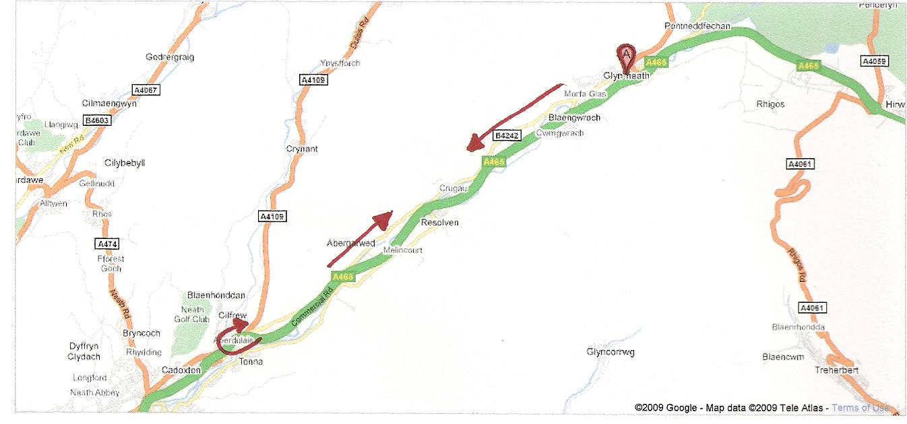

Transition 1 and 2 within the blue line, Red shows direction of bikes, black is direction of runners.
The red box is the mount and dismount line and will be indicated by a single yellow line. (the mount line will be closer to the transition area and not as indicated here.)

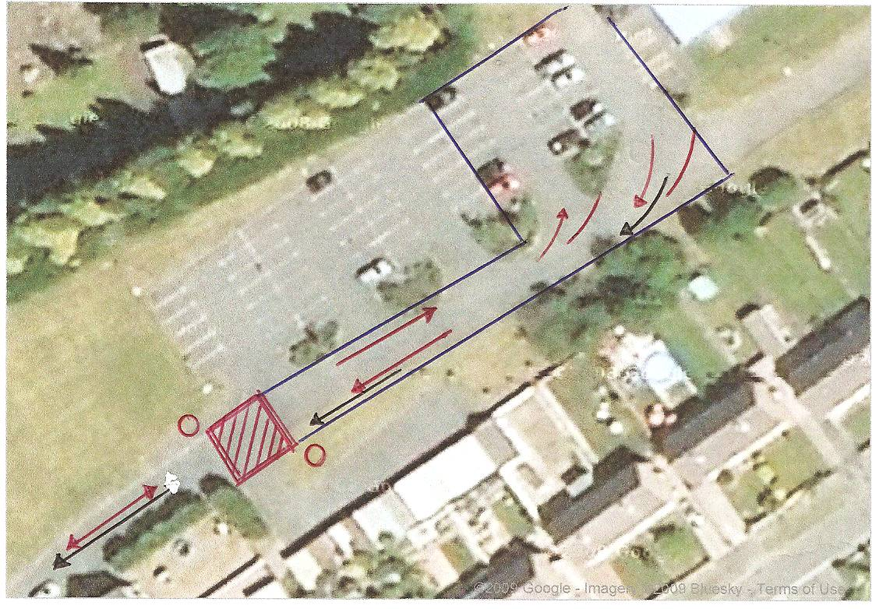

The Bike and Run section as you leave and return to the Pool car park onto B4242. Bike in red, Runners in black. Please note the you will need to adhere to the Highway code and BTF rules at junctions, Marshals will Not stop traffic for you and there will be a FOOT DOWN rule at junctions

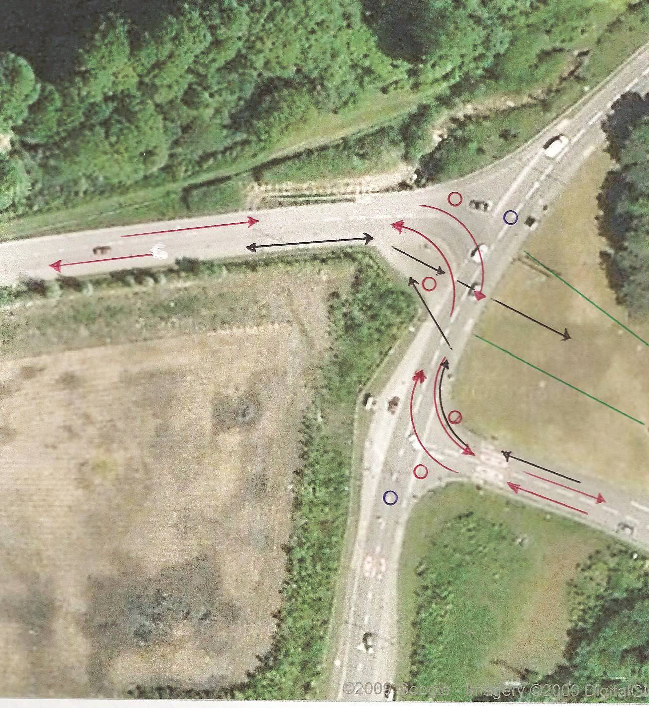

Turn Around point near Ground Hog, Aberdulais. B4242, 11 Km point.

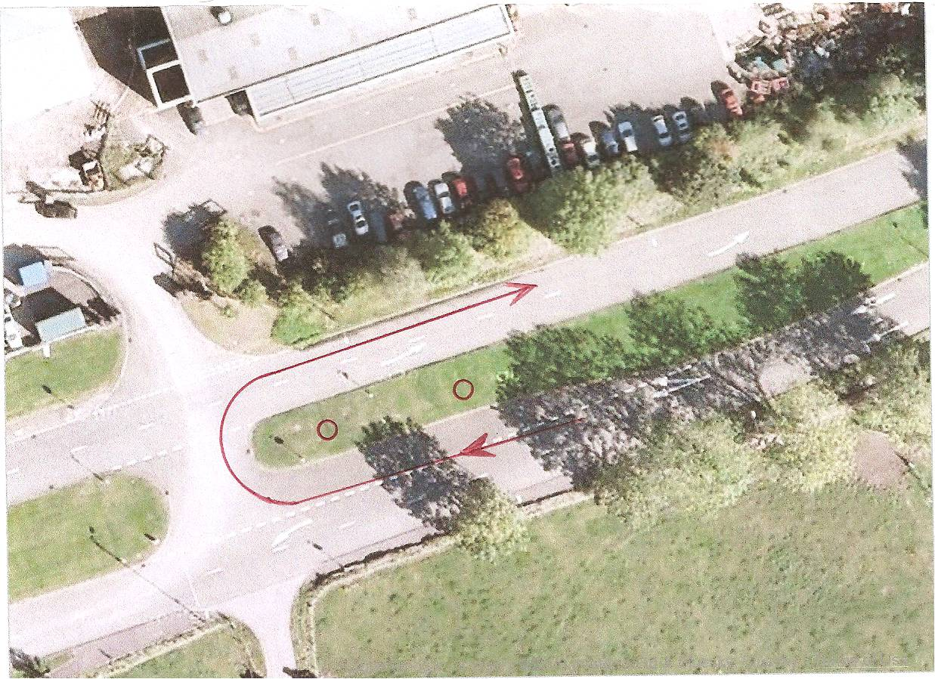

3km Run section (Run in red, cycle in blue)
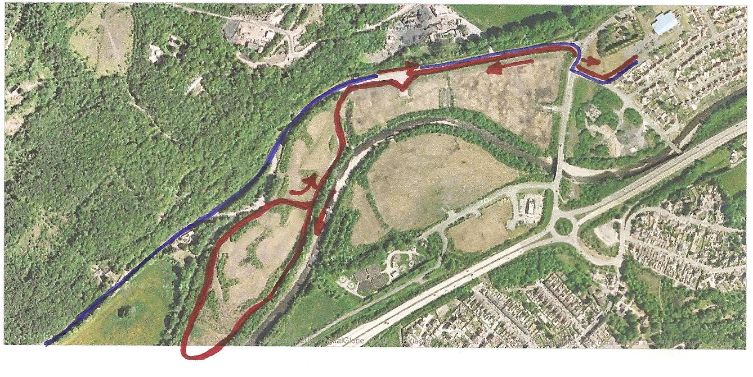
The finish line will be adjacent to the car park where you started off from, along the grassed area to the finishing arch.

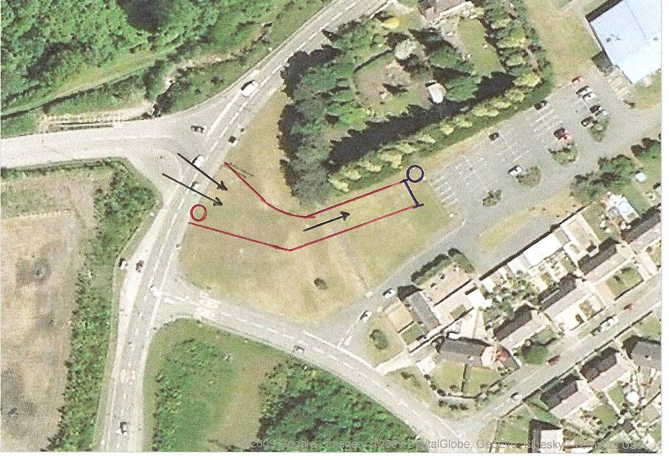
Well done you have now completed your race…

There will be a water station at the end of the race near the finishing arch, but please be sure to bring your own water bottles for the bike section.

Awards presentation will be at the end of the race around 1pm in around the transition area.
We will have awards for the 1st,2nd and 3rd Male and Female in the below categories-:
Youth (Ages 14-19), Senior (20-29), Veteran (40-49), Super Veteran (50-59), Vintage Veteran (60-69)
For those who place in the top three overall, you are unable to also claim age category podiums.

Rule hints and tips

- Transition area- There is no riding your bike in transition.
- Tri box- These are no longer allowed to be left in transition other than in a designated area, a small soft bag is allowed to be left in your transition area.
- Drafting - Drafting is not allowed in this race, it is where a cyclist tucks in behind another cyclist to avoid oncoming wind and making his or her race easier. See British Triathlon drafting rules.
- Mount line - This is the designated area marked out where you push the bike to from transition and then and only then do you mount your bike, likewise it is where you dismount the bike on the return from the bike section.
- Tri suit- A specially designed suit that most triathletes wear, an all in one swimsuit with padded shorts for the bike (not compulsory, tee shirt and shorts will do). If you wear a 2 piece suit you must not show any of your torso. Your zip must remain up if it is on the front of the tri suit.
- Number belt- A race belt can make your transition easier, it is an elasticated belt where athletes can pin their race numbers to. (Not compulsory, your number can be pinned on the front and back of your t shirt or running top.
- Music Earphones – No music equipment is allowed to be used in the race.
- Race Numbers – These must be visible at all times on the Bike (facing backwards) and run (facing forwards) section.
- Swim section – No diving, no backstroke, no calf guards, no forward motion other than swimming.
- Helmets – These must be compliant to British safety standards and must be fastened prior to unracking the bike and must remain fastened until the bike is racked.
- Marshals and Race Officials have given up their own time to assist in the running of this event, at no time will abuse towards marshals be tolerated; any such abuse will result in disqualification
- Key transition towel size Limit: Maximum size is 12” × 12” (30cm × 30cm)—flannel size only. Larger towels cannot be laid out on the ground.
- When not in use, the small flannel must be placed directly inside your shoes or rolled up neatly directly under the transition racking bar

Dress appropriately for the weather, you want to be comfortable. If its raining you may want to put a thin rain jacket in transition to put on after the swim, if its sunny make sure you have sun cream.

Rules are there for fairness and safety, there will be, were possible be an’ inform’ and not penalise approach, however penalties may be enforced if required.

Check List.

Swim Swimwear, goggles, ear plugs and nose clip.
Bike Bike, HELMET, cycle shoes/trainers, shorts, cycle top/t-shirt (or tri suit), Race numbers (Race belt can be used) and drink
Run Trainers, socks (if wearing), t-shirt/top, shorts (you can however cycle and run in your swimsuits and top if you wish)

Other useful items

- Safety pins to attach numbers (supplied)
- FLUID – make sure you stay hydrated before, during and after the race,
- Shower equipment
- Talc for inside trainers (helps get them on quicker)
- Towel for after swim section (placed in transition to stand on,
- Towel for showering after the race
- Change of clothes
- Number/Race belt
- Change/money – the lockers at pool side take 50p pieces or £1 coins which are returned.
- Warm top for after the race.
- Practice putting on your tee shirt when you are wet,
- Pushing your bike by the seat and running with it as if running to the mount line, practice putting on the helmet before touching your bike and leave it on until after you have re-racked your bike

Looking forward to seeing you all soon
Any questions, please don’t hesitate to email me on events@celtictri.co.uk

Linzi Byrne & Kelly Davies (Race organisers) www.celtictri.co.uk

