

Neath Valley Triathlon
Glyn Neath Pool SA11 5HW
Sunday Sept.23th 2012

Follow A465 at J 43 M4 Llandarcy up to Glyn Neath or A465 Heads of the Valleys road down to Glyn Neath.
Sat Nav. Chain Road, Glyn Neath SA11 5HW

Race starts 07.00hrs Reg. open from 06.15hrs

PLEASE NOTE, IF YOU HAVE ENTERED A WTF / BTF MEMBERSHIP NUMBER WHEN REGISTERING FOR THE EVENT, YOU MUST PRESENT IT ON THE DAY OR A £3 DAY LICENCE MUST BE PURCHASED.
Race Information Pack

May I take this opportunity on behalf of Celtictri to thank you all for supporting this event.

Please take time to read the following; it is important for the smooth, safe and enjoyable running of the event.

Ieuan Jones, Race Organiser.

The first swimmers will be in the water for a 07.00 am Start.

WARNING: -
IF YOU MISS YOUR SWIM START WE CANNOT GUARANTEE THAT A SPACE WILL BE AVAILABLE FOR YOU TO SWIM AT A LATER TIME

Registration / Briefing
- From 06.15 am onwards, in the Foyer of the pool complex.
- Registration will be open for approx 90 mins after the first wave has started.
- Here you will be issued with your timing chip, race number and bike sticker. Timing chips need to be placed just above the left ankle to avoid tangling with bike chain, not on the wrists.
- Bikes must be racked 1 hour before your start time correctly , please avoid congestion with other athletes starting the bike section, Only competitors with timing chips will be allowed in transition.
- Race briefing will be at 06:50 at the car park / entrance to pool complex for all.
- This is a non draughting race and race referees will be present.

Numbers

The numbers should be visible to marshals, on front and Rear of your vest/top and on bike frame. Race belts are permitted.

It would also help if you shouted out your number to marshals at transition timing areas – at exit of the pool, when leaving bike compound and at finish.

Swim section

- The first wave of the swim will begin at 07.00 hrs sharp. The slowest swimmers will start first. Please remember your race number and be ready to swim when requested by the swim marshals.
- Please assemble ready to swim at the changing room end of the pool 15 minutes before your allocated wave time.
- There will be 3 lanes with 3 swimmers in each lane. Please swim in a circular route, UP and DOWN the side indicated by the swim marshals.
- You may be provided with a coloured swim cap for easy identification by the lane marshals.
- Your 16 lengths (400 meters) must be counted by yourself. Lane counters will advise you when you have “2 lengths to go” and when to “finish”. It is your responsibility to ensure you swim the correct distance.
- On completion of the swim, please leave poolside by the exit indicated and make your way to the bike transition area, as shown. Please leave the swim hats with the marshal as you exit the water.

Leave your clothing for the bike and run sections by the side of your bike in the bike transition area, Tri boxes will be allowed.
Do not leave clothes in the way of other competitors – keep them neat. A clean site is a safe site.

Cycle section

Please try to have a number visible on your back and be ready to shout out your number to marshals.
- Any competitor slipstreaming behind another competitor may be disqualified. There should be at least 4 bike lengths between cyclists, except when overtaking.
- Be sure to fasten your helmet BEFORE un-racking your bike
- Do not mount your bike until you reach the “mount” line indicated on the floor by a marshal and a visible line
- The cycle section of this race consists of approximately 11 kms each way along the B4242.

Run section

On completion of the cycle section, leave your bike racked in the transition area (not on the ground).
IMPORTANT: Do not remove your helmet until you have racked your bike or you may incur a two minute penalty.
The run course is predominately on tarmac, but please be careful on uneven ground.

The Route.

22 km Bike ride, From Vale of Neath pool to “Ground Hog” at Ynys y Gerwn, Aberdulais and return along B4242 to pool car park.
(Not the A465 ByPass)

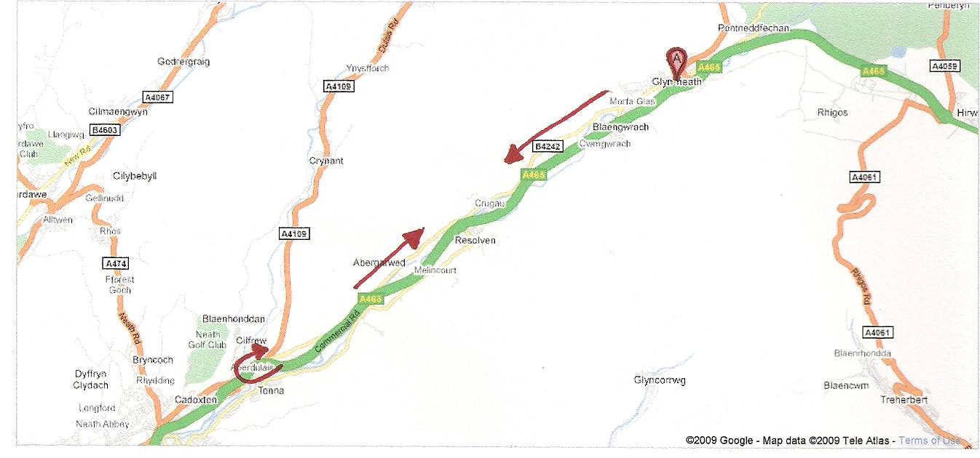

Transition 1 and 2 within the blue line, Red shows direction of bikes, black is direction of runners.
The red box is the mount and dismount line and will be indicated by a single yellow line.(the mount line will be closer to the transition area and not as indicated here.)

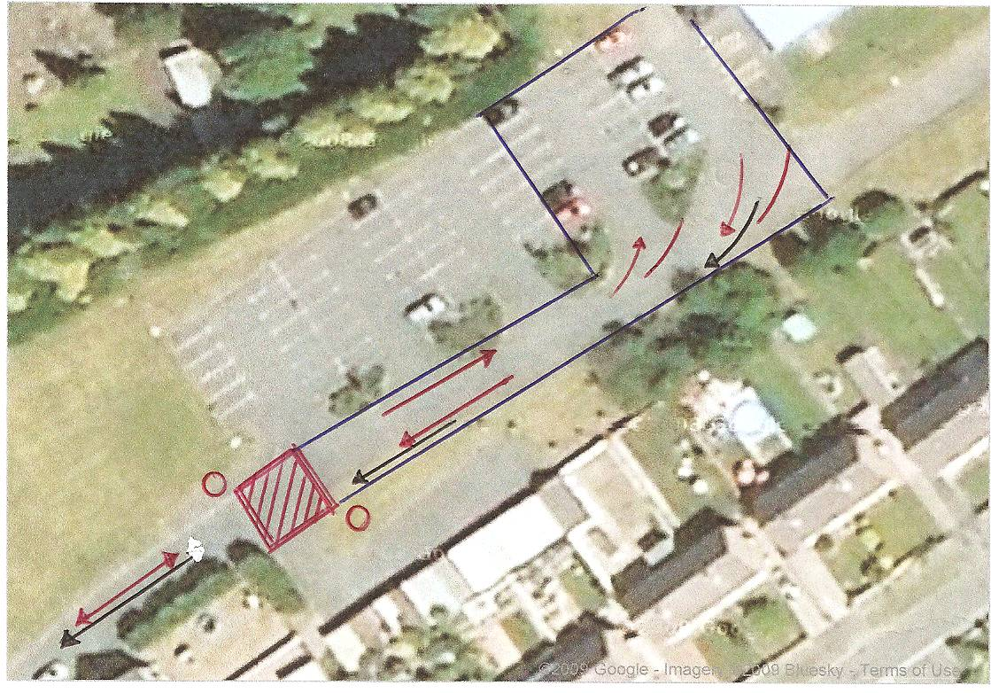

The Bike and Run section as you leave and return to the Pool car park onto B4242. Bike In red, Runners in black . Please note the you will need to adhere to the Highway code and BTF rules at junctions, Marshals will Not stop traffic for you.

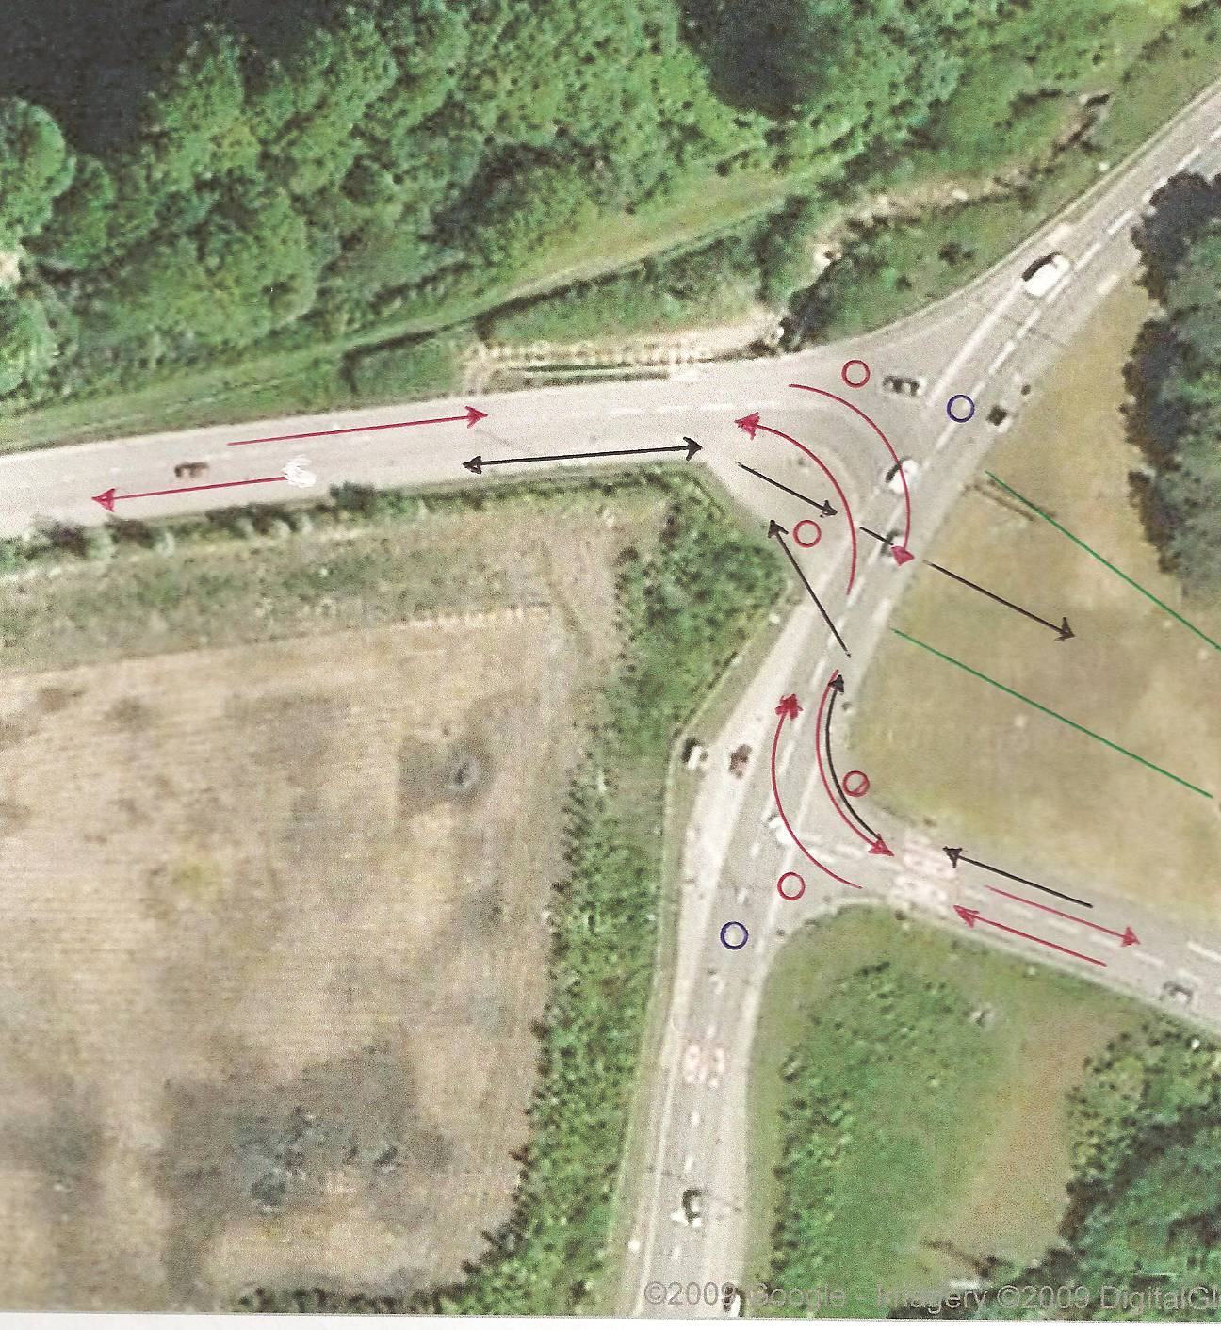

Turn Around point near Ground Hog, Aberdulais. B4242, 11 Km point.

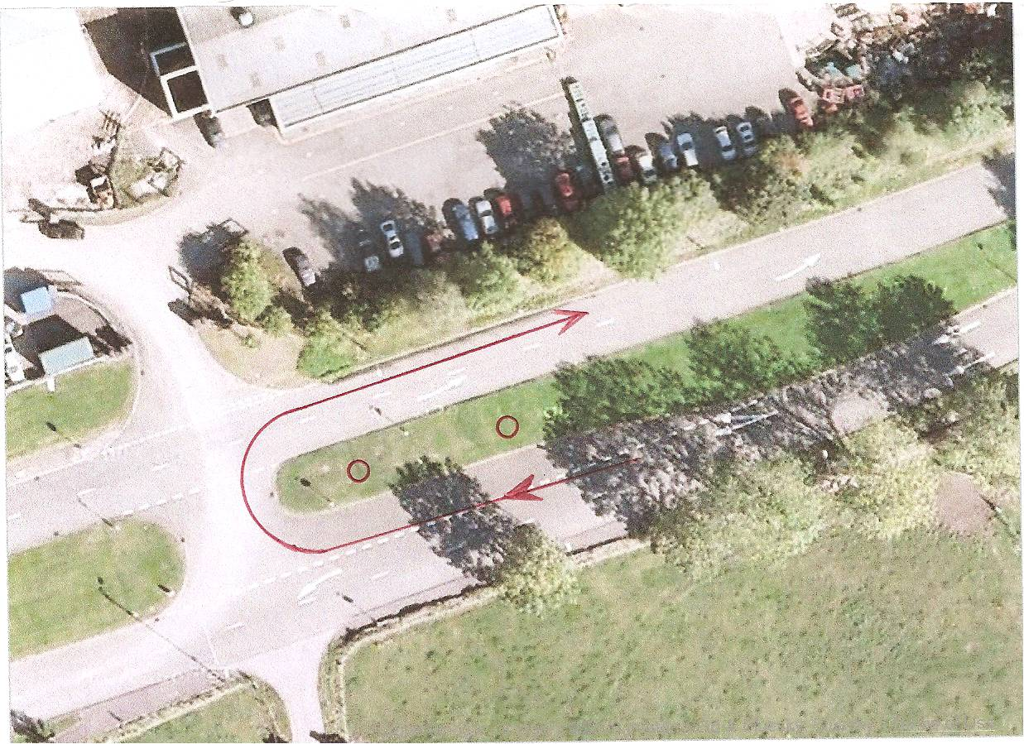

3km Run section (Run in red, cycle in blue)

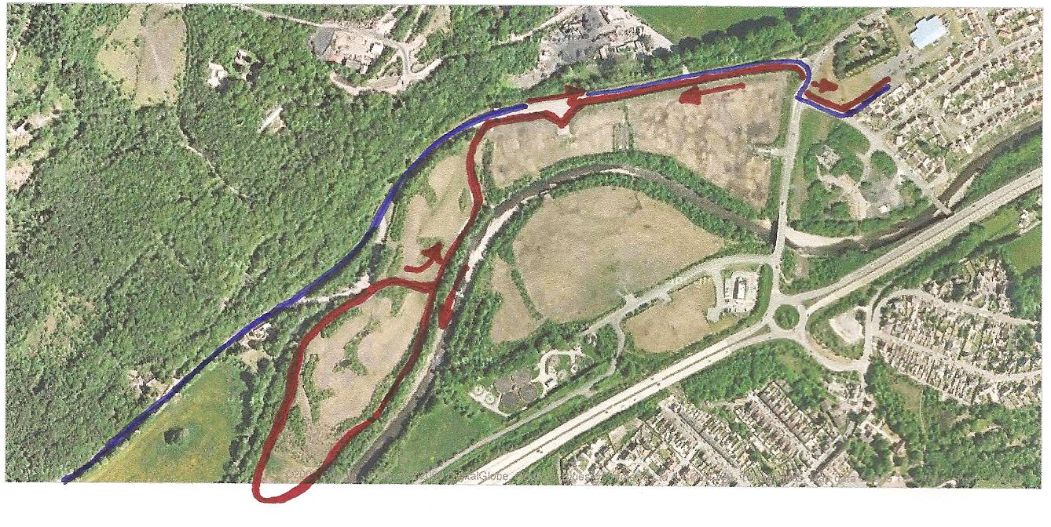

The finish line will be adjacent to the car park where you started off from, along the grassed area to the finishing arch.
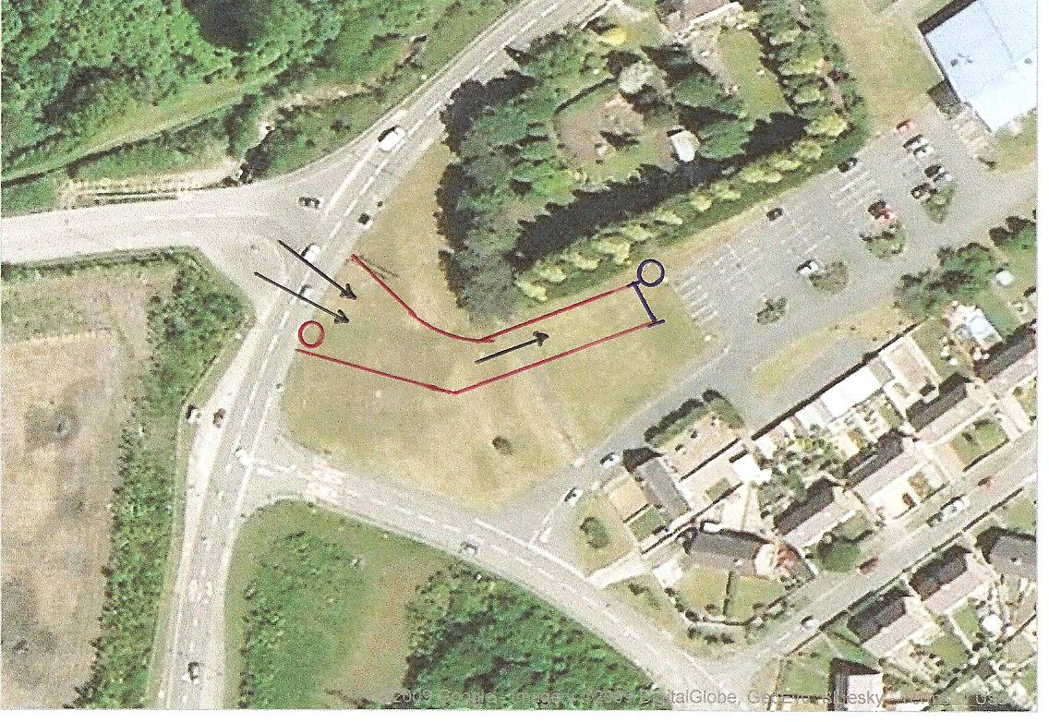
Well done you have now completed your race…

There will be a water station at the end of the race near the finishing arch, but please be sure to bring your own water bottles for the bike section.

IPods, MP3 Players or any other form of audio listening devices are not allowed during the event. If anyone is seen wearing any audio listening equipment during the event they may be disqualified.

Marshals and Race referees have given up their own time to assist in the running of this event, at no time will abuse towards marshals be tolerated; any such abuse will result in disqualification.

Glossary (For novices)

Transition area- this is where your bike will be racked and where you change from swim to bike, bike to run.
Timing chips- small electronic devices which strap to your left ankle and activate a timing signal when you cross over the timing mat.
Tri box- A Storage box for all your clothing, goggles, shoes, helmet, drinks, gels etc, stored when racing, usually placed next to your bike in Transition.
Slipstreaming- Slipstreaming or draughting is not allowed in most triathlons, it is where a cyclist tucks in behind another cyclist to avoid oncoming wind and making his or her race easier.
Mount line- This is the designated area marked out where you push the bike to from transition and then and only then do you mount your bike, likewise it is where you dismount the bike on the return from the bike section.
Tri suit- A specially designed suit that most triathletes wear, A all in one swimsuit with padded shorts for the bike and a zip up top for the run section (not compulsory, tee shirt and shorts will do).
Number belt- Elasticated belt where athletes can pin their race numbers to. (Not compulsory, your number can be pinned on the front and back of your tee shirt or running top.)

Check List.

Swim Swimwear, goggles, ear plugs and nose clip.
Bike Bike, HELMET, cycle shoes/trainers, shorts, cycle top/t-shirt (or tri suit) N.B: your torso must be covered when on bike/run section), Numbers .
Run Trainers, socks (if wearing), t-shirt/top, shorts (you can however cycle and run in your swimsuits and top if you wish)

Other useful items / tips.

Safety pins to attach numbers (supplied)
FLUID – make sure you stay hydrated before, during and after the race,
shower equipment
talc for inside trainers (helps get them on quicker)
towel for after swim section (placed in transition to stand on,
towel for showering after the race
change of clothes
number belt
Change/money – the lockers at pool side take 50p pieces which are returned
warm top for after the race.

Practice putting on your tee shirt when you are wet,
Pushing your bike by the seat and running with it as if running to the mount line, practice putting on the helmet before touching your bike and leave it on until after you have re-racked your bike

Below is the complete race list, please note the numbers you have been allocated, these are the numbers you will have in your race packs. You will start the swim according to your swim time, the lowest race number will go first, I.E. 1,2,3,4,5 First…………117,118,119,120. Last.

Please be at pool side in 15 mins before your est. swim time
First off at 07.00 hrs

Summary of Triathlon Rules

Any equipment that acts as an impediment to hearing or concentration is prohibited from use during the event (i.e. no MP3 players etc.)

No glass containers shall be used at any time.

Competitors are ultimately responsible for their own safety and for the safety of others.

It is the competitors’ responsibility to be properly prepared for the event and to ensure that their equipment is suitable and fit for its intended purpose.

Competitors must be adequately clothed at all times (Do not take your top off during the Cycle or run stages)

Competitors must not receive any assistance other than that provided by the race organisers.

Athletes must not bring helpers, friends or family members into the transition area.

Cycles must be racked.

Competitors MUST mount their cycle outside the transition area.

Competitors MUST dismount their cycle outside the transition area.

During the cycle phase a race number must be displayed to the rear.

During the run phase a number must be displayed to the front.

No diving at start of swim.

All competitors must follow the normal rules of the road.

Helmets must be fastened before the cycle is moved, and must remain fastened until the cycle is racked.

Competitors are not allowed to draft (i.e. come within 3 meters of the cycle in front. The overtaken cyclist should drop back.)

Failure to comply can result in time penalties or disqualification.
THE WEARING OF A CYCLE HELMET (WHICH MEETS APPROPRIATE BRITISH STANDARDS) IS COMPULSORY – REMEMBER NO HELMET, NO RACE!!
Don’t forget your WTF /BTF cards (if you have them)
Any questions, please don’t hesitate to mail or ring me, I would also welcome any feedback be it positive or negative in relation to how the event was run so we can implement or change any points arising.

www.celtictri.com
www.sportysnaps.com

THE RIVERSIDE, ABERDULAIS

Fire Training Wales

